UNIVERSITY ADMIT ELIGIBILITY PREDICTOR ASSIGNMENT - 4

|  |  |
| --- | --- |
| Date | 27th October 2022 |
| Team ID | PNT2022TMID54388 |
| Student Name | P.K.Raghul (310619106106) |
| Domain Name | Education |
| Project Name | University Admit Eligibility Predictor |
| Maximum Marks | 2 Marks |

1.)IMPORT THE REQUIRED LIBRARIES

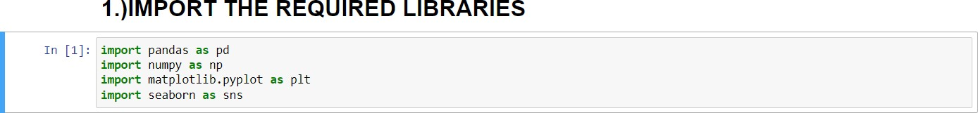

2.)DOWNLOAD AND UPLOAD THE DATASET

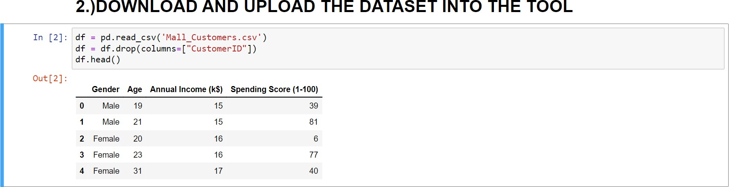

3.)CHECK FOR MISSING VALUES AND DEAL WITH THEM

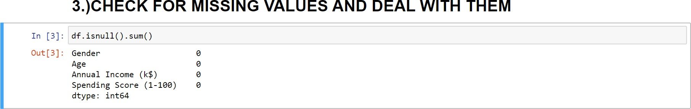

4.) PERFORM THE DESCRIPTIVE STATISTICS ON THE DATASET

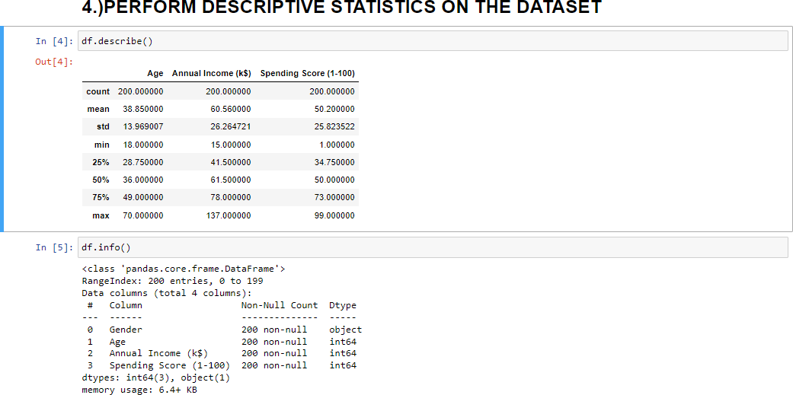

a.) UNIVARIANTE ANALYSIS

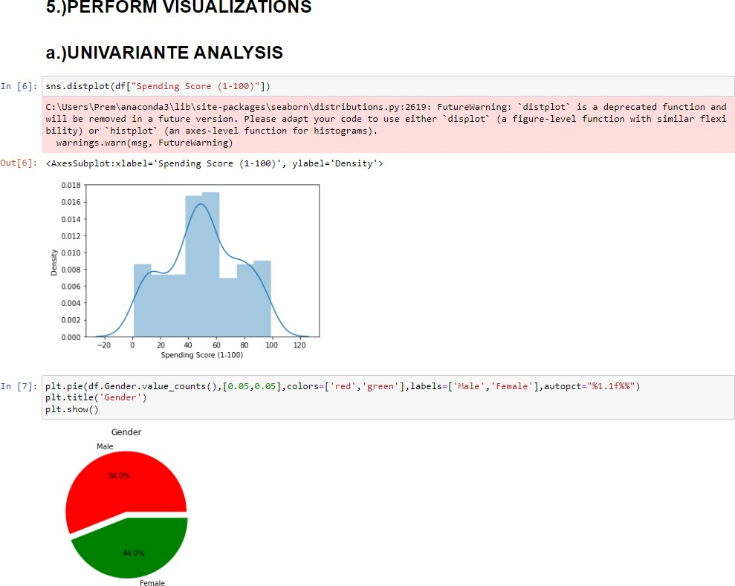

b.) BI - VARIANTE ANALYSIS

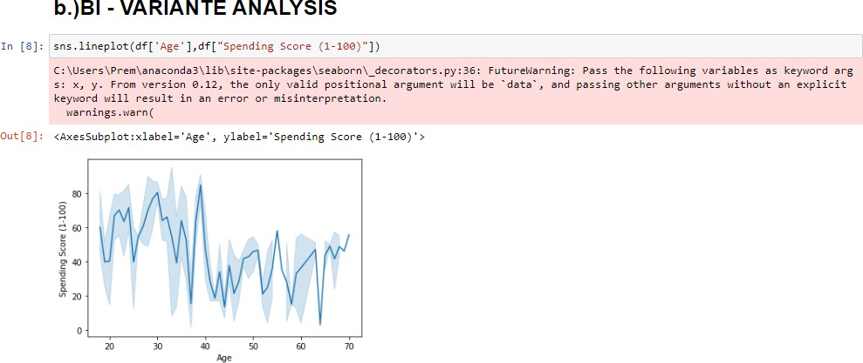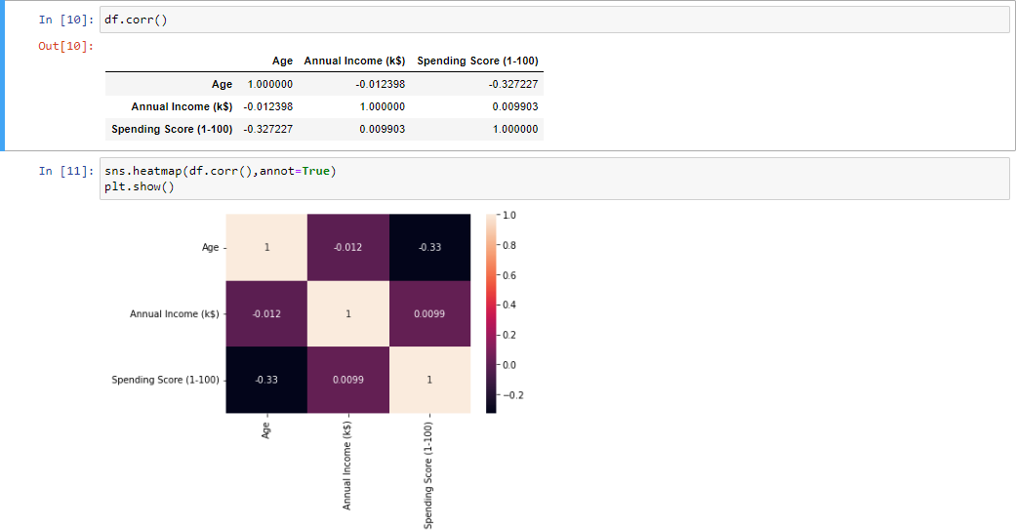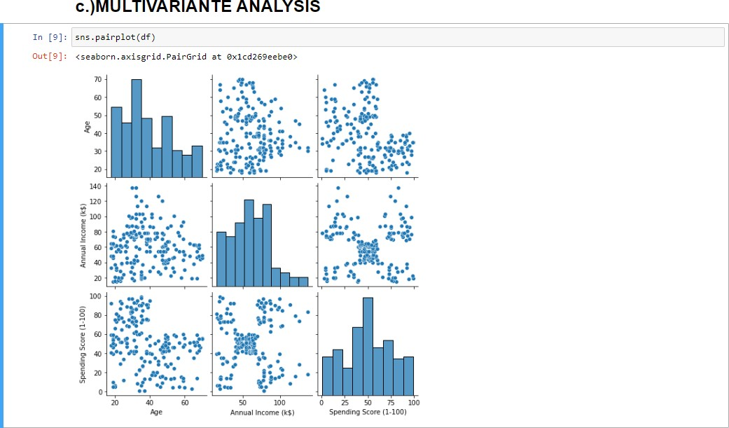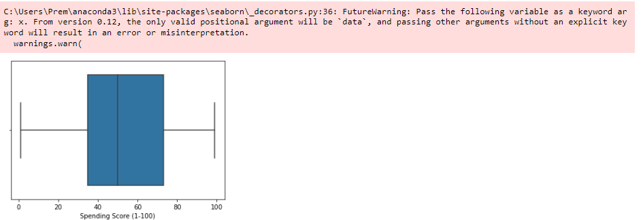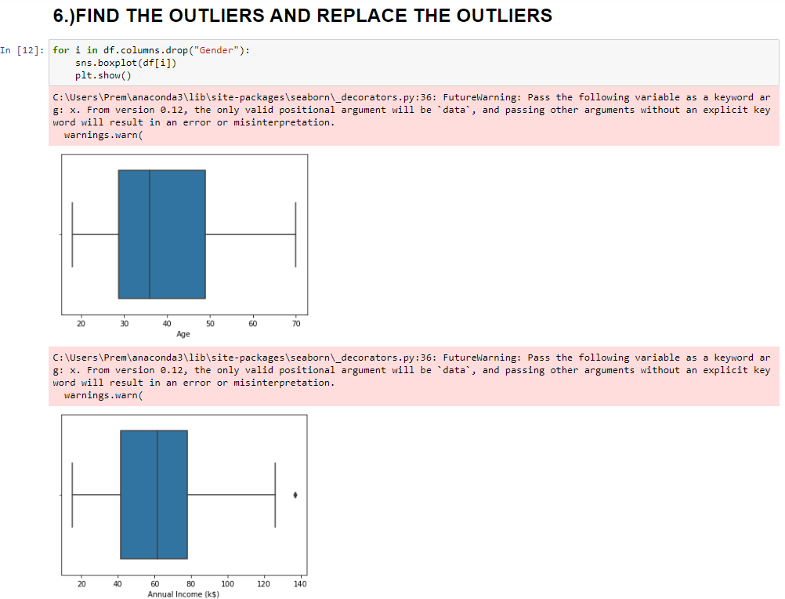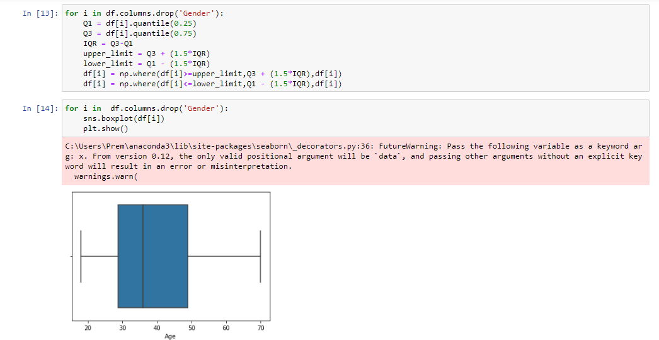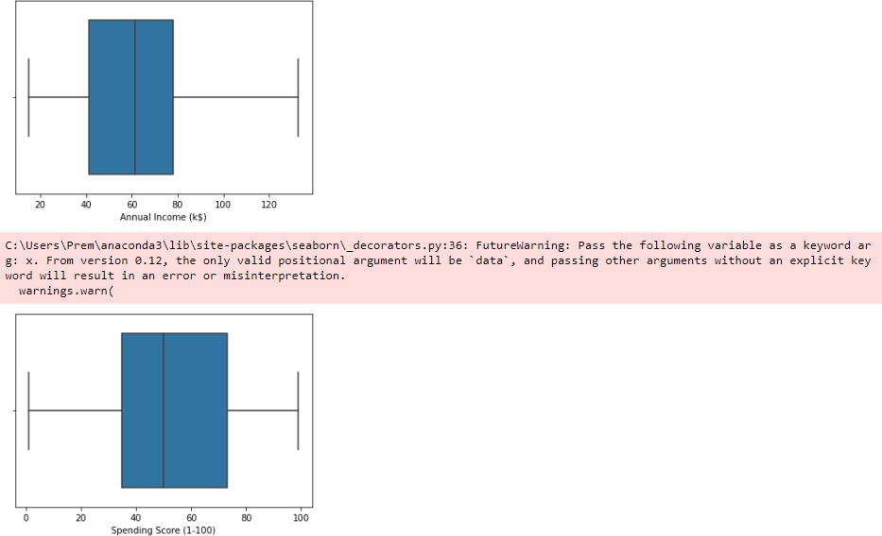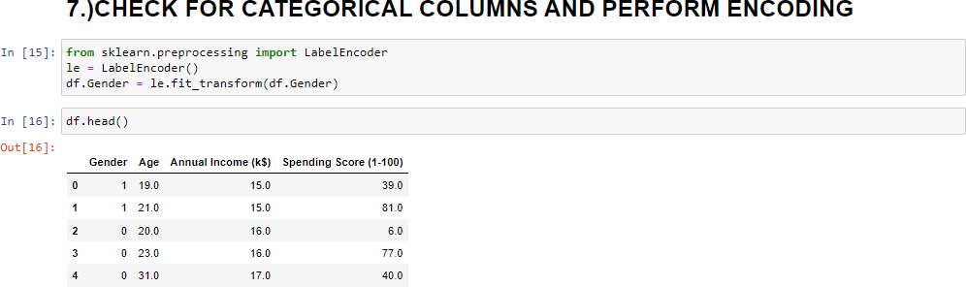

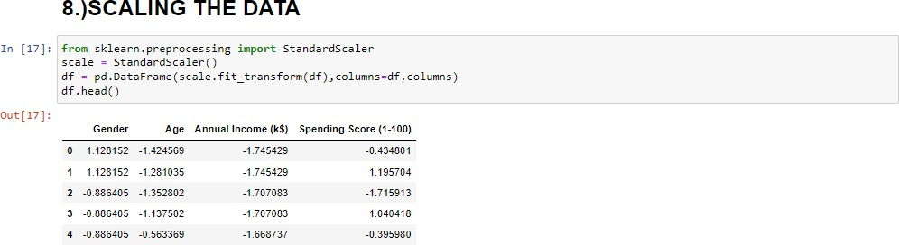8.) SCALE THE DATA

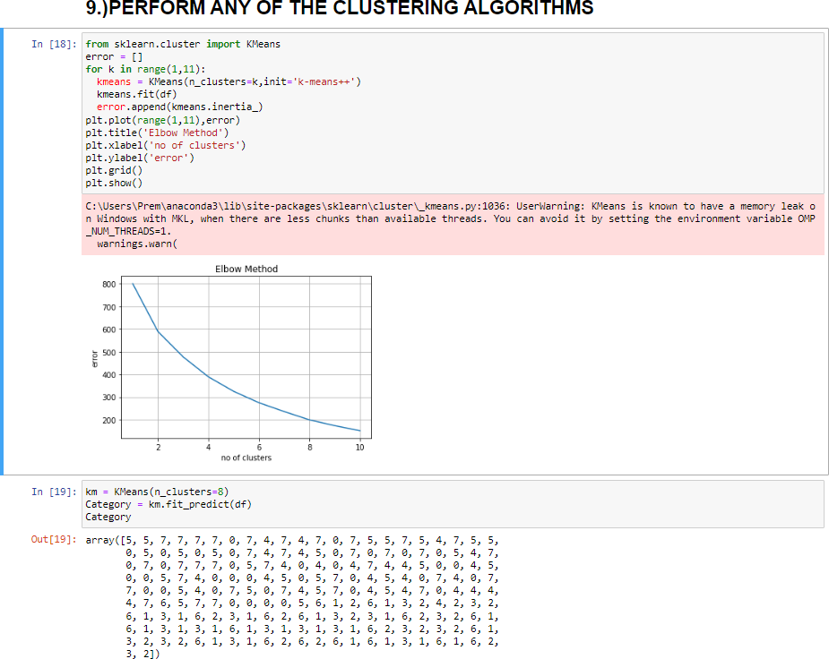

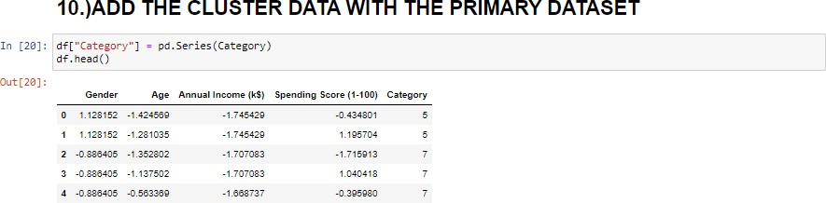10.) ADDING THE CLUSTER WITH THE PRIMARY DATASET

**VARIABLES**

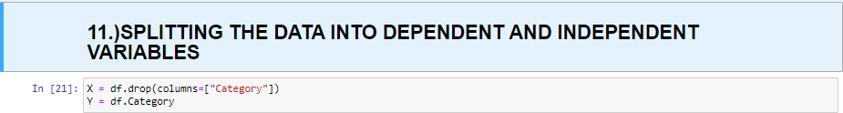

12.) SPLIT THE DATA INTO TRAINING AND TESTING DATA



13.) BUILD THE MODEL



14.) TRAIN THE MODEL

